 | Available online at  www.optimresearch.com/index.php/josa/index | JOSA
 | Journal of Safety Analytics  01 (01) 2026 | JOSA

Title of Manuscript (Capital Letter of Each Word; Font type: Segoe UI; Font size: 14; Align Center)
Full Name1, Corresponding Author1,*, Author2 (All Authors names must be written in a FULL NAME; Font type: Segoe UI; Font size: 9; Paragraph: Align Center) Taner Yigit¹, Erkan Celik²
¹ Directorate of Planning and Urban Planning, Mus Municipality, Muş, Türkiye

²Department of Transportation and Logistics, İstanbul University, İstanbul, Türkiye

Article Info |  | Abstract
Article history  Received XX Month 2026  Revised XX Month 2026  Accepted XX Month 2026  Published 1 March 2026 |  | Abstract should state a short introduction of background study, problem statement, purpose of the research, briefing about the used method, principal results and major conclusions. These six items should be included in abstract section (Compulsory). Citation or References and non-standard or uncommon abbreviations should be avoided in the abstract. The number of words should not exceed 350.
Keywords

Keyword1
Keyword2
Keyword3

DOI:

Citation: Yigit, T., & Celik, E. (2025). Analyzing the emergency assembly points criteria using the best-worst method under interval type-2 fuzzy sets. Journal of Information Analytics, 1(1), 23-37.
 This work is licensed under Creative Commons Attribution-NonCommercial 4.0 International License.
Corresponding Author: Erkan Celik erkancelik@istanbul.edu.tr

- Introduction
The first sentence should start here (Celik and Yiğit, 2025)]. Should have one spacing after section header. Content in body paragraph should be written with the Font style: Segoe UI; Font size: 10; Font Paragraph: Justify; Line spacing: 1.25. For example: Disaster management systems aim to prevent, mitigate, or eliminate the impacts of any disaster, regardless of its type. These systems involve coordinated planning that encompasses pre-disaster phases (risk reduction and preparedness) and post-disaster phases (response and recovery), ensuring the efficient and purposeful use of resources for the benefit of society and all living beings. Earthquakes, the most common natural disaster in our country, are a primary focus for disaster risk management efforts. As part of these efforts, emergency assembly areas were designated in collaboration between AFAD and municipalities in 2018.
Generally, in manuscript, should have: 1. Introduction (research background and Literature Review); 2. Methodology; 3. Result; 4. Conclusion; Acknowledgment; References. You may add more if required. The style of the section header as bellow:
1. Introduction (Capital Letter of Each Word; No indent; Font style: Calibri & Bold; Font Size: 12)
1.1 Sub Section Header (Capital Letter of Each Word; No indent; Font style: Segoe UI and bold; Font Size: 12)
1.1.1 Sub sub section header (Sentence case; No indent; Font style: Segoe UI and italic; Font Size: 12)
In the last paragraph of introduction section, Authors should highlight the gap and significant of the research before write the objective of the research. These three items are very important and compulsory. ---End of Introduction Section---
- Methodology
For manuscript publication, all provided Figures must follow the standard of quality for publication. Authors must provide a high quality with high resolution Figure. Content in the Figure should be clear and readable as shown in Figure 1(b) (Especially, the font size of contour legend). For example, as in Figure 1. The font size of Figure caption is 10.
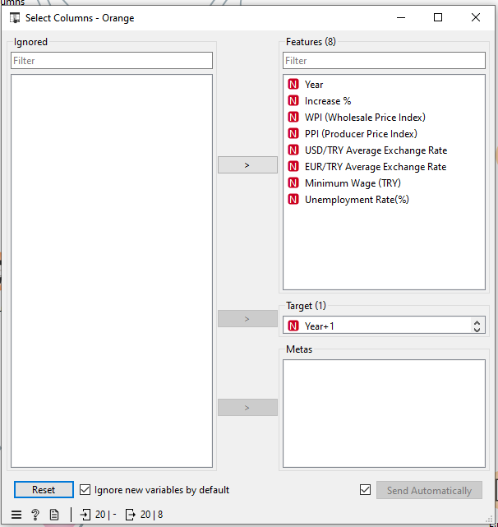
Figure 1. Determining target data (Font style: calibri; Segoe UI; Font Size: 10)

Each Figure must be discussed or mentioned in a body paragraph. The Figure must be placed under the paragraph that discussed about the Figure.
Table 1. Linguistic terms for importance weights (Celik et al. 2015)
Linguistic term | IT2FSs
EMI | ((8;9;9;10;1;1), (8.5;9;9;9.5;0.9;0.9))
IV8 | ((7;8;8;9;1;1), (7.5;8;8;8.5;0.9;0.9))
VSMI | ((6;7;7;8;1;1), (6.5;7;7;7.5;0.9;0.9))
IV6 | ((5;6;6;7;1;1), (5.5;6;6;6.5;0.9;0.9))
SMI | ((4;5;5;6;1;1), (4.5;5;5;5.5;0.9;0.9))
IV4 | ((3;4;4;5;1;1), (3.5;4;4;4.5;0.9;0.9))
MMI | ((2;3;3;4;1;1), (2.5;3;3;3.5;0.9;0.9))
IV2 | ((1;2;2;3;1;1), (1.5;2;2;2.5;0.9;0.9))
EI | ((1;1;1;1;1;1), (1;1;1;1;0.9;0.9))

Table should be placed at the center. Each Table must be discussed or mentioned in a body paragraph. The Table must be placed under the paragraph that discussed about the Table. Font style and font size of content in the Table are Segoe UI and 10, respectively. The content must be align center. The font size of Table caption is 10.
- Results
For example: This section discusses the results obtained from the disaster operation management study.

- Conclusion
In conclusion part, Author should highlight the finding of their research that respond to the research objective. For example: The main criteria are land preference, electric infrastructure, sanitary plumbing system, safety and security, and proximity.
Acknowledgement
This research was funded by a grant from Ministry of Higher Education of Malaysia (FRGS Grant R.J130000.7824.4X172).
(Note: This part is compulsory. If this research was not funded by any grant, please write “This research was not funded by any grant”)
Conflicts of Interest
Author A has received research grants from Company A. Author B has received a speaker honorarium from Company X and owns stocks in Company Y. Author C has been involved as a consultant and expert witness in Company Z. Author D is the inventor of patent X.
If no conflicts exist, the authors should state:
The authors declare no conflicts of interest.
References
The list of references should only include works that are cited in the text and that have been published or accepted for publication. Personal communications and unpublished works should only be mentioned in the text. Reference style should be in APA.
Altay, B. C., Celik, E., Okumus, A., Balin, A., & Gul, M. (2023). An integrated interval type-2 fuzzy BWM-MARCOS model for location selection of e-scooter sharing stations: The case of a university campus. Engineering Applications of Artificial Intelligence, 122, 106095.
Çelik, E., 2017. A cause and effect relationship model for location of temporary shelters in disaster operations management. International Journal of Disaster Risk Reduction, 22:257-268.
Celik, E., Akyuz, E., 2018. An interval type-2 fuzzy AHP and TOPSIS methods for decision-making problems in maritime transportation engineering: the case of ship loader. Ocean Engineering, 155, 371-38

